Accident Policy

At Ellergreen Nursery School and Childcare Centre, we are committed to providing a safe and secure environment for all children, staff, and visitors. We recognise that accidents and incidents may occur during the operation of Ellergreen Nursery School and Childcare, and therefore, we have implemented a thorough Accident Policy to ensure that appropriate actions are taken promptly and effectively. This policy is in line with the Early Years Foundation Stage Framework and reflects our commitment to safeguarding and promoting the welfare of children.

The implementation of our Accident Policy is paramount in ensuring that we maintain a culture of safety. By prioritising the well-being of our children and staff, we not only mitigate risks but also foster an environment where learning and exploration can take place without undue fear of harm. This document outlines our objectives, the roles and responsibilities of staff and leadership, first aid provisions, and the procedures we follow in the event of an accident.

The objective of our Accident Policy is to:
- Create a nurturing and safe environment for children, staff, and visitors.
- Minimise the risk of accidents and incidents within Ellergreen Nursery School and Childcare Centre.
- Respond quickly, effectively, and appropriately to any accidents and incidents that occur.
- Keep parents and guardians informed about accidents and incidents involving their child, thereby fostering open communication and trust.
- Continuously review and improve our procedures to maintain the highest standards of safety and care.

To fulfil these objectives, the roles and responsibilities for ensuring the effective implementation of the Accident Policy are clearly defined.

The Leadership Team at Ellergreen Nursery School and Childcare Centre holds critical responsibilities, including:
- Ensuring that suitable and sufficient arrangements are in place for the implementation of this policy. This includes establishing clear guidelines for reporting and managing incidents.
- Providing adequate resources and training for staff to maintain a safe environment. This involves regularly reviewing safety equipment and first aid supplies.
- Ensuring that all staff members receive regular training as necessary, particularly in areas such as paediatric first aid and safeguarding procedures.
- Reporting any serious accidents or incidents to the appropriate authorities as required, thereby ensuring transparency and compliance with legal obligations.

Staff members play a pivotal role in the execution of this policy, with responsibilities including:
- Being familiar with and adhering to all procedures outlined in the Accident Policy, thus fostering a consistent and cohesive approach to safety.
- Actively supervising children to prioritise their safety at all times. This directs attention to potential hazards and allows for immediate intervention when necessary.
- Reporting all accidents and incidents on the appropriate accident form or through the Famly App to ensure accurate record-keeping.
- Taking responsibility for the management and maintenance of accident records, thus contributing to our efforts to analyse and improve safety measures.
- Effectively communicating with parents and guardians regarding any accidents or incidents involving their child, using both paper formats and our online app for timely information sharing.

First Aid is a vital component of our Accident Policy. To ensure that we are prepared for any situation, we have established the following guidelines:
- First aid boxes will be conveniently accessible throughout Ellergreen Nursery School and Childcare Centre to ensure that assistance can be provided without delay.
- All staff members are trained in Paediatric First Aid, and a minimum of one qualified first aider will be present at all times during nursery operating hours.
- Any first aid administered will be documented accurately in the Accident Report Book or on the Famly application to maintain a record of care provided.

In the event of an accident, we have established a series of procedures that must be followed:
- All accidents must be recorded in the accident record book or the Famly electronic app, and on the head injury form if applicable.
- The recording of accidents must take place immediately after the incident occurs to ensure that accounts are accurate and detailed.
- A member of the Leadership Team must be informed of any serious accidents. This ensures that escalating matters receive appropriate attention.
- Parents or guardians must sign the accident book and head injury form, either as a paper copy or electronically via the Famly app. If signed on the premises, one copy of the accident record sheet is retained by the setting, while the other copy is given to the child to take home, accompanied by the head injury form. Furthermore, parents will be provided with an information sheet on concussion, either electronically or by hand, to ensure they are fully informed.
- In cases where a child requires hospital treatment, a member of the Leadership Team must:
  - Make every effort to contact the child's parent or guardian or their designated emergency contact.
  - Take all relevant information in respect of the child to the hospital, including medication records and sleep charts, to ensure that medical professionals have the necessary details for care.
  - To minimise distress, a staff member will remain with the child until the parent or guardian arrives, providing comfort and reassurance.
  - Where appropriate, the manager will liaise with the hospital social worker team to ensure that there is an adequate support system in place for the child.
  - If the child has a social worker, a member of the Leadership Team will ensure that all relevant information is conveyed to support ongoing assessments and care.

This Accident Policy at Ellergreen Nursery School and Childcare Centre forms the cornerstone of our commitment to maintaining a safe and secure environment for all individuals within our setting. By steadfastly adhering to this policy and continuously reviewing and improving our procedures, we aspire to uphold the highest standards of safety and well-being for our children, staff, and visitors. The health and safety of everyone at our centre is not only our legal obligation but a moral one, reflecting our dedication to nurturing a safe and positive educational experience for all

Accident Reporting and Recording

The following information must be recorded each time a child has an accident / injury, on matter how minor it may seem

- Name of the child being treated.

- Date of accident / injury.

- Time it occurred.

- Location where accident / injury occurred.

- Location on child of injury, if applicable head injury form should be completed.

- A brief description of the accident/injury should be written.

- Information relating to treatment / first aid/ action should be given.

- Member of staff completing accident/injury record sheet should sign relevant section.

- Information should be recorded relating to any follow up treatment ie hospital.
- Member of the Leadership Team should sign the sheet

- Parent/Carer should be informed and sign Accident/injury record sheet to confirm this sharing of information and take a copy of the sheet.

Ellergreen Nursery School and Childcare Centre

………………………………………………………….…………. has suffered an injury to the head. He/she appears to have recovered but you should seek medical advice immediately if your child:
- Vomits
- Becomes drowsy or unconscious
- Complains of double vision
- Has a discharge of blood or fluid from the nose or
ears
- Has a convulsion

Staff signature………………………………………………………………

Parent/carer signature ….………………………………………………..

Manager signature ………………………………………………………

Date/Time………………………………………………
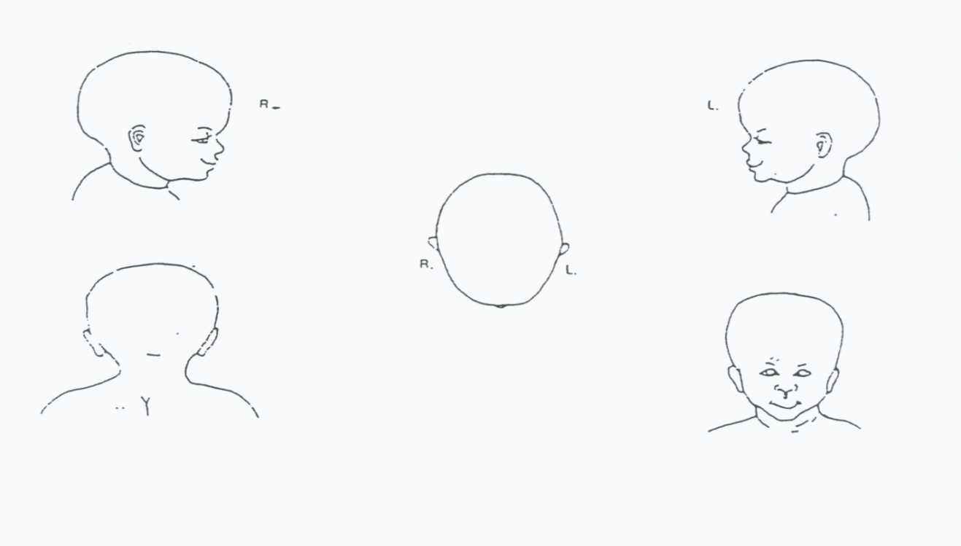

Review and Monitoring:

This Accident Policy will be routinely reviewed and updated as deemed necessary by The Leadership Team at Ellergreen Nursery School and Childcare Centre to ensure compliance with current legislation and best practice guidelines.

Policy Review Date: August 2025

Date: August 2026

