We Love Maths

At Ellergreen Nursery School we aim to promote a love of mathematics, whether it be number, shape or measurement. Our termly newsletter will provide you with information, activities and helpful sites to visit, to support the development of your child’s mathematical knowledge and skills through a play.

We Love Shape, Space and Measure
Mathematics is not just about the number! Shape, Space and Measure is essential to the development of children’s mathematical understanding and reasoning skills. What may appear as simple play with construction, jigsaws or filling and pouring, is in fact how our children begin to understand how shapes and objects work together (geometry) and how they develop an understanding of spatial concepts - ideas about location, relative position, symmetry, and direction. Spatial skills also improve children’s understanding of number and quantity, as it supports children to visually and physically experience quantity, promotes the ability to visualise numbers (thinking of five as three dots and two dots) and helps identify the relationships between numbers, such as where numbers sit on a number line or which numbers form other numbers e.g. 3 with 2 and 4 with 1 will make 5.
8
9 10
1 | 2 | 3 | 4 | 5 | 6 | 7

Shape
Learning about shapes begins with how young children identify what an object is. They know that a ball is a ball because of its shape, however anything that looks like a ball, such as an orange, may also be called a ball. This is why children need lots of opportunities to explore objects using their senses. As children’s knowledge of shapes grows and they begin to know the names of simple shapes, such as circles, squares and triangles, it is important that they understand shapes are all around them and may not always look the same - for example a clock, a wheel and a frisbee are all circles. Children will also begin to understand that shapes can be flat 2D (circle, triangle, square etc.) or solid 3D (cube, cuboids, sphere – box, book, ball), although will commonly identify 3D shapes as a familiar 2D shape, such as a ball (sphere) will be called a circle. It is therefore important that children are supported in recognising the features of shapes, for example, ‘Well done, the ball is round like a circle, but a circle is flat and a ball is solid’. A helpful way to explain this is if it is flat you can put your hands together, if it is solid your hands are apart.

Supporting your child to learn:
- Shape Hunt – First look at some simple shapes with your child. Here is a fun shape song your children may know - https://www.youtube.com/watch?v=pfRuLS-Vnjs. Now go on a shape hunt around the house, garden or when out and about. How many circles can they find? What looks like a square?
- Find Something Like This – Display a selection of objects of different shapes e.g. a plate, cup, book, picture frame, remote control, coaster. Now show your child a shape, such as a circle and ask them to find the objects that look like this shape. Talk about which parts of the object is the same and what makes them this shape i.e. one curved side.
- I Spy – This is a great game and can be adapted in so many ways, such as ‘I spy a circle’ or ‘I spy something with four straight sides’.
- Play with your Food – Introduce shapes through food, such as a pizza slice looks like a triangle or by cutting sandwiches into squares. Get your child to join in with cutting up their food to represent shapes.
- Songs and rhymes – There are lots of shapes songs and videos on YouTube which will help your child learn more about the features and names of simple shapes.
Super Simple Songs: The Shape Song #1 - https://www.youtube.com/watch?v=TJhfl5vdxp4
Sing Along Shapes Song https://www.youtube.com/watch?v=w6eTDfkvPmo


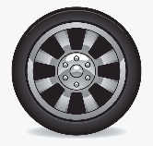
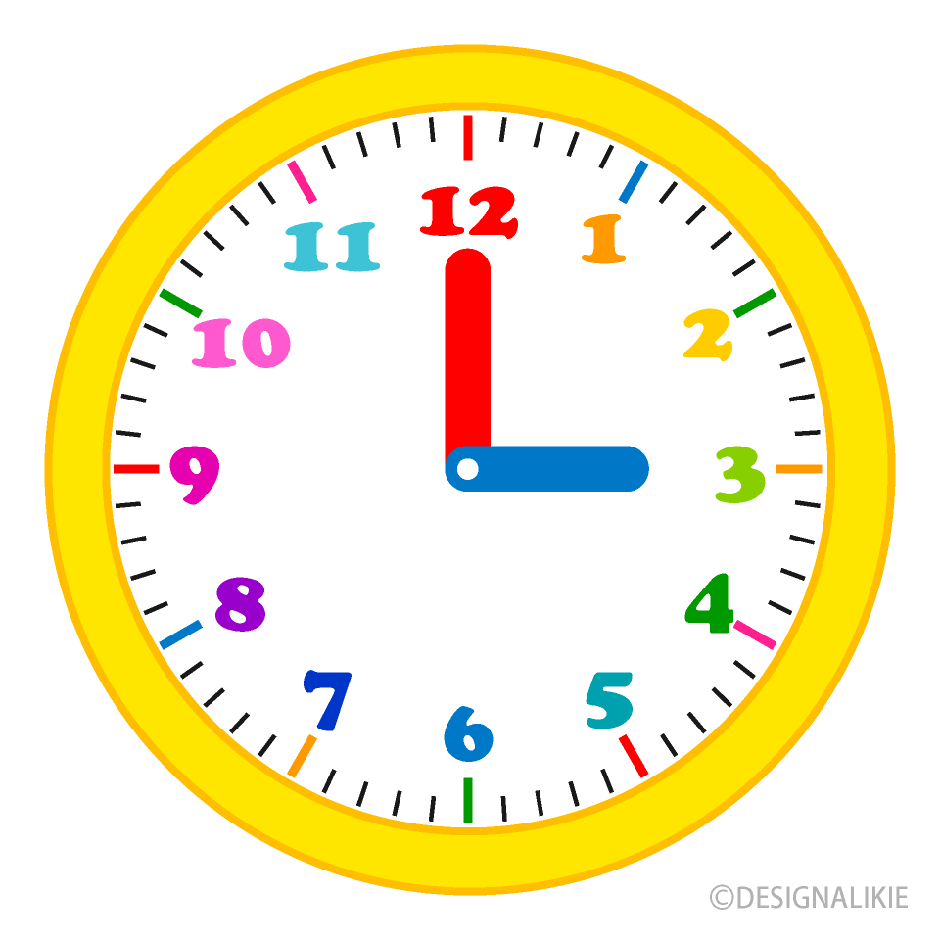
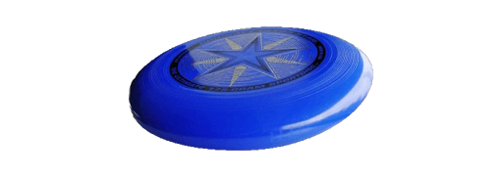

Space
In the early years ‘Space’ refers to several spatial concepts, including:
Simple location and position (the frog is on the log and the log is in the bog).
- Hide and Seek – This is a fun way to introduce prepositions, words that describe the position of an object or time e.g. on, in, before, after. When the seeker finds the hider, they must say where they are, for instance, ‘You are under the bed’.
- Where’s Teddy? – All you need is a toy and a box/container. Take turns in placing the toy either in, on, under, next to, behind and infront of the box. It is best to begin with two positions, such as on and in, then add more once your child is confident with these words.
- We’re Going on a Bear Hunt – This is a lovely story to read that uses repeated positional language. At school we add actions to represent over, under and through. Here is Michael Rosen the author reading the story - https://www.youtube.com/watch?v=0gyI6ykDwds
- Songs and Rhymes – Here are a few fun songs you can watch with your child and spot where the objects are:
Jack Hartman Kids music: All Around the farm -https://www.youtube.com/watch?v=ykmFyHJq6FY
Kids TV123: Where’s the monkey? - https://www.youtube.com/watch?v=idJYhjGyWTU
Scratch garden: prepositions Song - https://www.youtube.com/watch?v=xyMrLQ4ZI-4

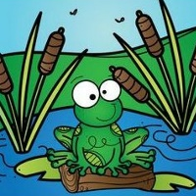

Spatial and body awareness (the physical experience of moving and navigating around a space, such as running outdoors or climbing over an obstacle course, helps develop the skill to form visual images of objects moving within a space, such as a jigsaw piece).
- Obstacle course – Build a simple obstacle course inside or out for your child to climb over, under and through. You could even challenge them to roll a ball around the obstacle course!
- Weaving Races – Challenge your child to weave between cones (or any objects, such as bricks) by walking, running or riding a bike.

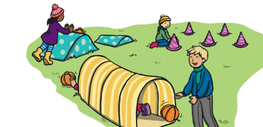

Direction and directional language (knowing how to get from one place to another: to find the treasure walk two steps forward, turn right then move 1 step sideways).
- Board games – Play board games with moving counters, such as snakes and ladders.
- Hidden Treasure – First hide a toy or a prize. Next draw a simple treasure map for your child to follow. Give your child spoken instructions, such as ‘Take three steps forward’, until they find the treasure.
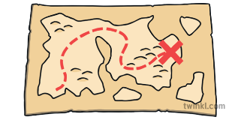

Measure
Measure is introduced in the early years through practical activities, such as building towers and filling different sized containers. We aim for children to develop an understanding of the relationship between size and space (the larger the bucket the more water it can hold). Hands on activities allow children to develop an understanding of what they are measuring, such as weight, length or time. Children learn to identify and compare the size or weight of objects through simple language, such as small or big. As their understanding of measure grows they are able to compare and order three or more objects and expand the language used to identify and compare, such as smallest, biggest, short/shortest, long/longest, light/lightest, heavy/heaviest.
- Filling and Pouring – Whether in the bath, in a sand pit or using dried rice provide your child with a couple of different sized containers to fill using fingers, spoons or spades. Talk to your child about which will hold the most or least. If they pour water from the small container will it fill the big container? How many small containers of water will they need to fill the big container?
- Building Blocks – Have fun building different sized towers and constructions with your child. Challenge your child to make a tower/construction that is bigger or smaller. Talk about what they will do to complete the challenge.
- Jigsaws and puzzles – spend time with your child completing simple jigsaws and shape puzzles, such as fitting a shape into a specific hole. Make your own puzzle using cardboard. First cut out a selection of different sized holes. Collect different items from around the house, such as a coin, ball and pencil. Then work with your child to see which objects will fit through each hole.
- How far? – This is an activity that introduces units of measure and can be adapted in lots of ways. Your child could get physical by seeing how far they can jump, they could throw a ball or bean bag, roll a car or even a cabbage. First decide how they will measure the distance; they could use footsteps, a tape measure or sticks (as long as each is the same size).
- Against the Clock – Using a timer or by counting to a number challenge your child to complete a task, such as build a tower or putting marbles in a jar. This helps to give them a sense of time.
- Hide and Seek – This is another great game to teach children about measurements of time. Count up to different numbers to make the time shorter and longer. Talk to your child about which number gave them the least or most time to hide.

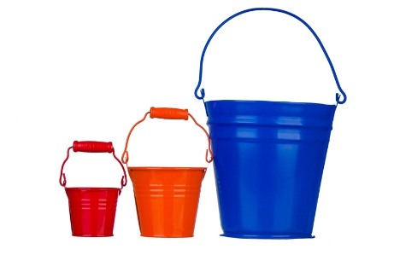

We would love to see pictures of your child’s maths adventures and hear about their achievements on Tapestry. You can also message us on Twitter if you would like to share your activities with our school community.

