We Love Maths

At Ellergreen Nursery School we aim to promote a love of mathematics, whether it be number, shape or measurement. Every half term, we will be providing you with information, activities and helpful sites to visit with your child, to support the development of their mathematical knowledge and skills through a relaxed, fun and holistic approach.

Counting
Children love to count! Counting is a very important skill as it helps us to order, sequence and identify quantities. Children need lots of different experiences and opportunities to count to ensure they develop confident counting skills. Begin by ordering a few numbers at a time, such as 1 to 3, then 1 to 5, building up to 10 and beyond, increasing by one or two numbers at a time.
8
9 10
1 | 2 | 3 | 4 | 5 | 6 | 7

Ordering
It is important children hear examples of counting, before they have a go.
- Races –Begin by counting from 1 to 3 at the beginning of a race, ‘1, 2, 3 go!’, extend this to ‘When I reach 5 you go - 1, 2, 3, 4, 5!’.
- Hide and Seek – Count to 10 and then beyond as your child becomes more secure at counting in order e.g. Count to 12 then come and find me…’. Try challenging your child to count backwards, ‘5, 4, 3, 2, 1’.
- Daily routines - Counting can even help getting children to brush their teeth or go to bed, ‘See if you can be tucked in bed, with your book, by the time I count to 15. Ready steady, go!’, ‘Can you count to 10 as you brush your front teeth?’ – this will definitely cause lots of giggles.
- Caterpillar ordering – Play this fun, free interactive game https://www.topmarks.co.uk/ordering-and-sequencing/caterpillar-ordering


Counting actions
- In, Out and About – count how many steps to the bus stop, count how many stairs in your house, count how many jumps to the kitchen, count how many claps for tidying the toys away, ‘Give yourself 6 claps for tidying your toys – 1, 2… 6’
- What’s the time Mr Wolf – a fun game best played outside.
- Simon Says – play a number version of Simon Says e.g. ‘Simon Says jump 4 times’.
- Play a Board Game – this is a great opportunity for children to identify simple number patterns on a dice. Children can count how many jumps, slides or bounces each counter takes as it travels around the board. You could even make a simple board game by simply drawing shapes across a piece of paper. If you don’t have a dice, write numbers on small squares of paper to pull out of a bowl – just like a raffle.



Counting objects
- Shopping – a great opportunity to count small amounts of objects, ‘Please get 3 tins of beans’. If your child needs more challenge get them to problem solve, ‘We need 5 bananas, but there are only 3 in this bunch. I wonder how many more we will need?’ – help your child count the additional bananas, ‘1, 2, 3… 4, 5. We needed two more’.
- Counting cars – play a game to see who can count 10 cars of a particular colour or make, first. Change the rules of the game to meet your child’s number knowledge
- Setting the table – a good counting and problem solving activity, ‘Please put forks out for Mummy, Daddy, Granny and Grandad. How many do you need?’
- Gingerbread Man game – choose from counting, matching or ordering the number of chocolate buttons on the gingerbread men
https://www.topmarks.co.uk/learning-to-count/gingerbread-man-game

Sequencing
Sequencing helps children recognise patterns and supports their later learning when making links between numbers, such as times tables.
- Paper chains – as Christmas approaches think about making homemade decorations which follow a simple repeating pattern. This could be a colour, shape or picture pattern e.g. red, green, red, green… star, triangle, star, triangle… snowman, Santa, snowman, Santa…
- Decorate a cushion – sew or stick different coloured buttons on a cushion. Why not use different sized buttons!
- Paint a picture – use cut vegetables to print a repeating pattern. Make the pattern trickier by adding an extra colour or shape e.g. yellow, blue, green
- Shape Patterns – have fun sequencing shapes with this interactive game https://www.topmarks.co.uk/ordering-and-sequencing/shape-patterns

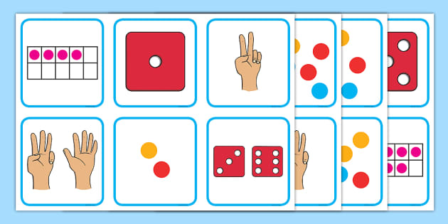



Subitising
This is when we recognise the number of objects in a small group without the need to count them – we just need to look. We subitise when looking at dice, dominoes or everyday groups of objects – ‘There are four apples in the fruit bowl’. Subitising is an important skill as it helps children to form images for numbers in their mind (to visualise), which then supports learning number facts, such as ‘There is a 2 and 3 in 5’.
- Roll, Count and Action – turn a cardboard box into a dice (chocolate orange boxes are great for this). Simply wrap it in paper, then draw dots on each side 1-6. Now take turns to roll the dice and do a chosen action the number of times shown on the dice.
- Board games – play a simple board game with dice, similar to Snakes and Ladders. A good way to personalise the game is to draw your own; this means you can choose how many moves you want to do and you can use their favourites toys as counters. If you don’t have a dice cut up small pieces of paper and draw dots from 1-6. You can then take turns to pick a number from a bag or tub.
- Dots on a picture – draw or print a picture of something your child likes, such as fish or a bus (pictures attached at end of document). Provide them with either dot stickers or small circles of paper/foil/cellophane/sequins to decorate.
- All around – simply chat with your child about what is around them, such as ask ‘How many fingers do you have? Make sure you hold up your or their hand to look; ‘How many ice-cream scoops are in your cone?’; ‘How many smarties are in your hand?’.
Remember children will begin to subitise small numbers between 1-3 at first. We would also expect them to want to count, just to check. Subitising is about repeated experiences and developing a visual memory of quantity.

We would love to see pictures of your child’s maths adventures and hear about their achievements on Tapestry. You can also message us on Twitter if you would like to share your activities with our school community.

How Children Learn About Number in the Early Years
Children best learn about number through lots of play, which includes numbers - verbally, visually and simple problem solving. This requires many complex skills; understanding of mathematical language, working memory and visualisation, are just a few. Most children learn about number in stages, although the age at which children develop mathematical skills can vary greatly!
One-to-one Correspondence

Children repeat number names they hear, without knowing their meaning.

2 ½ yrs

Number Names

As children remember ever increasing number names, they must also learn to say them in the correct sequence.

From
3 yrs

Number Sequences

Children learn, as they count a group of objects, the last number they say is the amount of objects in the group.
Cardinal
Values

4 yrs

Children begin to count in different ways and can count on from a number other than one. They can demonstrate an understanding of what fewer and more means.

5+ yrs

Forwards Backwards
Fewer
More

Children learn that numbers can mean different things: ‘I am four’, ‘There are four blocks’. They will visualise numbers in different ways, such as
spots or fingers on a hand.
fingers on their hand.
Visualisation

4 - 5 yrs

Children learn how to subitise alongside other number skills. This is when we recognise the number of objects in a small group, without the need to count them.
Subitising

4 - 5 yrs

Children count small groups of objects by matching a number name to each one. Most children will point to each object as they say the name, therefore skill relies on hand and eye coordination.

3+ yrs

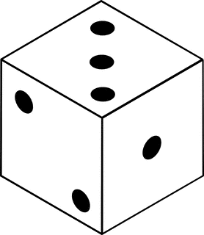
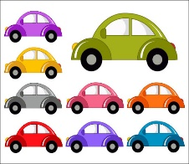
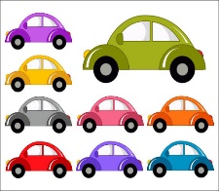
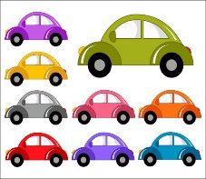


“4 cars”
“3 spots”

For further information about how children learn about numbers visit:- https://www.theschoolrun.com/early-years-number-skill



