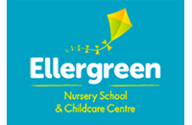

Ellergreen Home Reading Books
Our Book Bags
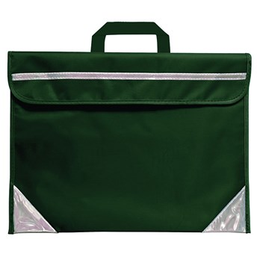
The book bag is for your child to use whilst he/she is at school with us. It is to keep the books clean and dry on the journey to and from school and home.
Inside of the bag you will find a book which your child has chosen, a reading diary for your child to record their favourite part of the book, a ‘Tips for Reading with Young Children’ letter and question card/s which you can use when talking to your child about the book.
Books
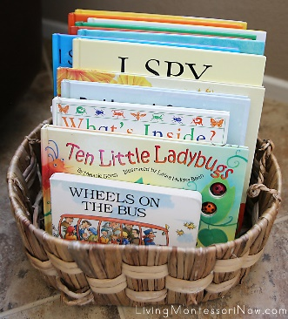
Every Wednesday the children will choose a new book to take home for the week. Please send your child into school with their book bag, previously borrowed book and reading diary on this day.
We would like to encourage you to share the book with your child by looking at the pictures, reading the text to your child and allowing your child to retell the story in their own words, as many times as they would like. There are some helpful tips included in the book bag with more information to support reading with children.
Please help your child to take care of our books. We would ask that you do not eat or drink when looking at them with your child and beware of younger siblings with pencils and pens – they do enjoy adding their own stamp. However, we do understand accidents do happen, especially with young children.

Happy reading everyone!

