How Children Learn Early Reading Skills
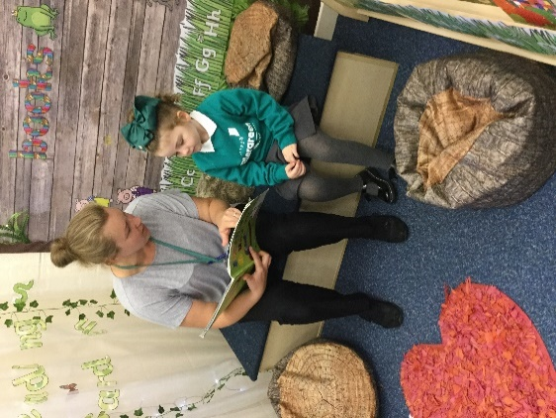
Reading together: Sharing books and stories is essential to children developing reading skills.
At Ellergreen Nursery School and Childcare Centre we understand that children learn best when they are engaged and excited about their experience. Therefore, our primary focus is to develop a love of language and reading through our children’s natural curiosity and interests.
We also know that before children learn to read, they must first build a foundation of pre-reading skills, including motivation to read, language and communication skills, concepts of print, letter knowledge and phonological awareness. These are some of the ways in which we support our children to develop these pre-reading skills:

Promoting Talk and Building Vocabulary
We understand talk is a crucial tool when learning and the first stage to developing literacy skills. We also know that quality interactions and experiences of broad vocabulary are essential to becoming good readers. At Ellergreen we promote talk through:
- Allowing time for children to talk and respond. It is essential for children to have time to think when experiencing new things or when exploring an activity and that they be given the opportunity to start a conversation, even if it is just “Look!” – then we know it is our turn to join in.
- Identifying and sharing the children’s interests through activities, books and daily chats.
- An exciting and engaging environment that promotes wonder, investigation and discussion.
- By adults modelling spoken language and communication with others; by using a breadth of language and giving child friendly explanations, for example – “ ‘The giant was ginormous!’ That means it was very, very, very big. Bigger than your house”.
Enabling Environments
We provide the children with rich and enabling environments, that promote language and the exploration of letters, sounds and text:
- Following the child’s interests – planning resources and play opportunities that represent the children’s interests and allow them to explore new and exciting possibilities.
- Signs and labels - with both picture and text e.g. name labels, resource labels, area signs.
- Literacy in play, for example: menus, price lists, recipes, leaflets and books.
- Mark making, such as: painting, drawing, price tickets, shopping lists, letters, cards and maps.
- Book areas and reading snugs – cosy, quiet areas for children to read independently or share books, poems and rhymes with friends and adults.
- Reading and picture Books – high quality books (fiction, non-fiction, poems and rhymes) are freely accessed throughout encouraging children to share their voice using questions and prompting e.g. ‘What do you think…?’, ‘Remember after you went down the slide, you (pause)’.
- the environment, to enjoy independently or share with friends and adults.
Enabling Adults
Throughout the busy day, adults demonstrate the various purposes of reading and writing, actively engaging the children through play and daily routines:
- Modelling reading – books, signs, instructions and information online.
- Modelling writing – using writing as a part of play and to record information and ideas during carpet time.
- Labelling children’s work as they talk about it – pictures, models, mark making.
- Completing daily tasks with the children –register, naming and handing out letters, completing lists.
- Drawing attention and explaining the purpose of text in the setting – signs, labels, books.
Nursery Rhymes, Songs and Music
We know that nursery rhymes, songs and music are so important for language development and developing an ear for rhyme and rhythm, which helps children to hear sounds and syllables in words. Nursery rhymes and songs also introduce children to storytelling skills, including inferencing, comprehension and memorising, all essential for good readers. Children are encouraged to explore music and song through:
- Musical instruments and musical prompts within the learning environments - nursery rhyme puppets, books and pictures; nursery rhyme and song interactive displays; playing recordings of nursery rhymes and songs.
- Singing and playing together – explicit teaching sessions; daily routine songs e.g. welcome song, days of the week; nursery rhymes and seasonal songs; number songs.
- Charanga and Charanga Yumu – online support for teaching music at school and at home.
Story Time
Reading is one of the most important parts of our day, so as well as sharing books, reading and writing with the children through play, we also dedicate a specific part of each session to ‘Story Time’. This is when:
- Language is brought alive and meaning is given to printed words.
- A breadth of new vocabulary is introduced and meaning taught.
- Children join in with storytelling - practicing how to change their voice to represent meaning and characters; memorising and repeating recurring phrases; developing an understanding of rhythm and rhyme within words.
- Topics are introduced and children learn about life, people and the world.
Phonics: Letters and Sounds
At Ellergreen Nursery School we know it is essential for children to develop the foundation skills on which they can build a comprehensive phonological knowledge. This begins with the quality teaching of Phase 1 phonics and providing the opportunity for children to embed their skills over time. Our priority is to support children to:
- Become attuned to the sounds around them – this supports children to identify the sounds individual, paired and grouped letters make.
- Listening to and remembering sounds – children will develop the ability to replicate and sequence the sounds they hear in words.
There are 7 aspects of Phase 1 Letters and Sounds, which we practice with our children throughout the year, beginning with aspect 1. Below are the aspects explained with just some of the activities we do with our children:
- Aspect 1: General sound discrimination – environmental sounds
Children learn to focus their hearing, so they are able to recognise and compare the different sounds they hear around them, such as birds singing, a car engine, people chattering.
What we do: Go for sound walks, make music using everyday objects, for example banging a wooden spoon on pots and pans or moving it across fences; play sound lotto games, using recorded environmental and animal sounds.

- Aspect 2: General sound discrimination – instrumental sounds
Children develop an awareness of to recognise and replicate different types of sounds, which supports them when listening for and making different letter sounds.
What we do: play and compare the different sounds of instruments; make our own instruments to play; play instruments to music and stories.

- Aspect 3: General sound discrimination – body percussion
Children learn about sounds and rhythms by using their body like an instrument e.g. clapping and stamping. This supports children to identify the sounds and rhythms we hear in spoken words.
What we do: Sing action songs and rhymes – ‘If you’re Happy and you know it’; play and make sounds along to music, using parts of our bodies e.g. tapping our knees.

- Aspect 4: Rhythm and rhyme
Children develop recognition of the rhythm and rhyme in speech and words, through lots and lots of experiences.
Aspects 5, 6 and 7
It is important when introducing the sounds of letters to children we have a good knowledge of how letters should sound. Please see our video to hear the A-Z of Phonemes on your child’s class page or follow this link to hear all 42 phonemes
(letter sounds) in the English language
https://www.youtube.com/watch?v=-ksblMiliA8
.

What we do: Read rhyming stories; play rhyming bingo using pictures or objects; clap out the syllables in words, such as our names e.g. Ell – er - green.

- Aspect 5: Alliteration
Alliteration - when the same letter or sound begins neighbouring or closely connected words, within a sentence or phrase e.g. The big blue ball bounced over a bear.
Children develop the ability to distinguish the initial (first) sound in words.
What we do: Read stories which include alliteration; play I-Spy type games – ‘I spy something beginning with…’; describing people and objects using alliteration – Jumping Jamie; Go for objects hunts, finding objects that begin with the same sound.

Aspect 6: Voice sounds
Children learn to hear and identify the difference in vocal sounds, including segmenting (separating the sounds in words cat, /c/-/a/-/t/) and oral blending (listening to the separate sounds in words and blending them to make a word /c/-/a/-/t/, cat).
What we do: Replicate the sounds of objects and animals; change the sounds of our voices such as loud, quiet, stretchy, bouncy; Talk like a robot e.g. /s/-/i/-/t/ down; add sounds to stories.

- Aspect 7: Oral blending and segmenting
Children will further develop their oral blending and segmenting skills, which is essential for reading words as they learn the sounds individual letters make in Phase 2.
What we do: Play sound talk games; play I Spy type games, sound talking an object/person’s names; play Copy Me – teacher sound talks a word /c/-/a/-/t/, children repeat the sounds.

